TITLE OF YOUR EXTENDED ABSTRACT (TNR, Bold 14pt centered)
Author A¹, Author B², Author C³ (TNR 12pt centered)
¹Affiliation, City, Country
²Affiliation, City, Country
³Affiliation, City, Country
E-mail (Corresponding Author)
- INTRODUCTION
The International Conference on Measurements of Energy (ICME 2026) invites original research contributions addressing recent advances, challenges, and applications in energy measurement and metrology. Authors are required to submit an extended abstract not exceeding two (2) A4 pages, including figures, tables, and references. Manuscripts must be written in English using single spacing, Times New Roman 12 pt, with 25 mm margins on all sides.
- METHODOLOGY / EXPERIMENTAL APPROACH
This section should briefly describe the experimental setup, material measurement techniques, instrumentation, calibration methods, numerical models, or analytical approaches used in the study.
- RESULTS AND DISCUSSION
Key findings should be clearly presented and discussed with respect to energy measurement accuracy, uncertainty analysis, and metrological relevance. Figures and tables must be embedded in the text, centered, and properly captioned.
- USING THE TEMPLATE FOR SEVERAL COMPONENTS
  - Equations
Equations should be centered and numbered consecutively, as in Eq. [1]. An alternative method is given in Eq. [2] for long sets of equations where only one referencing equation number is wanted.
(1 line spacing here)
 |  | [1]
where, | (1 line spacing here)
 |  | [2]

  - List
Lists can be provided using either numbers or bullets:
- List item 1 like this;
- List item 2 is an example of a longer list item that wraps to a second line, where the second line is indented.
The example for bulleted items like this:
- List item 1;
- List item 2.

  - Tables and figures
Tables and figures should appear in one column of a page and be numbered consecutively. Figures and texts may appear on the same page, and a centered caption should appear directly beneath the figure. It is preferable that figures be mounted in portrait style and figure captions are no longer than two lines. On figures showing graphs, both axes must be clearly labeled (including units if applicable).
Tables should be designed to have a uniform style throughout the paper, following the style shown in Table 1. Table captions should be in 10pt “Time News Roman” bold, centered, and the texts in Table should be set in 9pt “Time News Roman” font.

Table 1. Caption heading for a table should be placed at the top of the table and within table width.
(Use “time news roman” font, size 10pt, No spacing after table title)
 | A | B | C | D
A | Aa | Ab | Ac | Ad
B | Ba | Bb | Bc | Bd
C | Ca | Cb | Cc | Cd
D | Da | Db | Dc | Dd
E | Ea | Eb | Ec | Ed
Authors are advised to prepare their figures in either black and white or color. Please prepare the figures in high resolution (300 dpi) for half-tone illustrations or images. Pictures must be sharp enough otherwise they will be rejected. Figures must be originals, computer-generated or drafted, and placed within the text area where they are discussed. Figure 1 shows one example. Figure captions should be in 10pt “Time News Roman” font, bold, centered. When applicable, the texts in graphs, illustrations or images should be set in 8pt “Time News Roman” font.
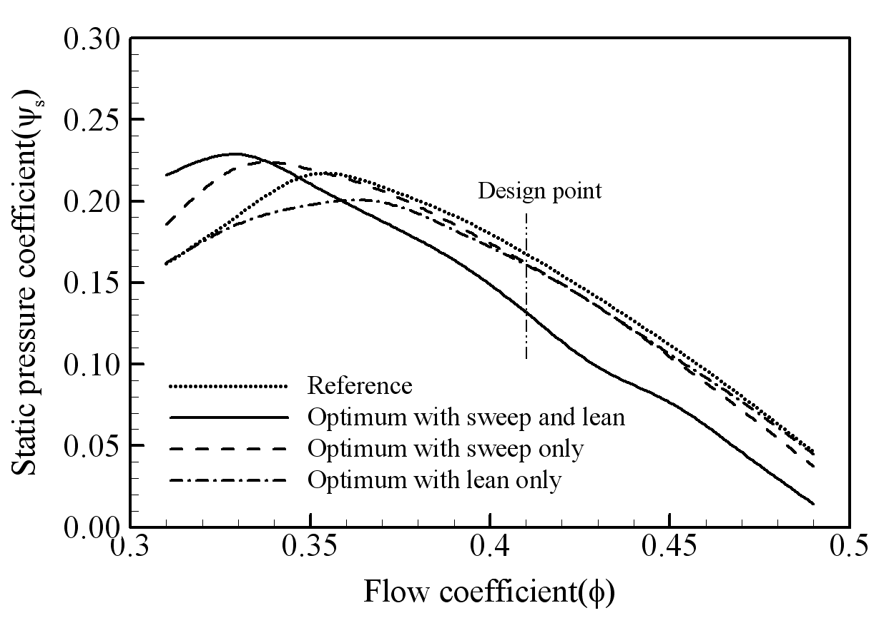
Figure 1. The caption heading for a figure should be placed below the figure and within figure/illustration width. (Use “Time News Roman” font, size 10pt, no spacing between title and figure)

  - Footnotes
Footnotes are denoted by a character superscript in the text b.

  - Units
Use either SI (MKS) as primary units. English or CGS units may be used as secondary units (in parentheses). Avoid combining SI and CGS units. This often leads to confusion because equations do not balance dimensionally. If you must use mixed units, clearly state the units for each quantity that you use in an equation. Do not mix complete spellings and abbreviations of units. Spell out units when they appear in text.

- CONCLUSIONS
Summarize the major outcomes of the work, key contributions to energy metrology, and potential applications or future research directions.
ACKNOWLEDGEMENT (Optional)
The authors acknowledge the support of funding agencies or institutions, if any.
REFERENCES
References should be listed arranged in alphabetical order beginning with the author’s names and initials, followed by the year of publication, title of periodical, volume and page. Example:
Smith, J., Kumar, R., and Lee, M. (2023). Measurement uncertainty analysis in smart grid energy systems. Measurement, 210, 112345.

b Just like this one.

